

Team Purrfect

Table of Contents

Basic Informations : 4
3cs : 4
Fake Screenshots : 5
Scope : 6
Gameplay intention : 7
Mechanics : 7
Potion Brewing : 7
Candle Crafting : 9
Crystal Gathering : 11
Water / Plant Harvesting : 12
Interactions / Wandering : 13
Upgrades : 14
NPCs : 14
Systems : 15
XP system : 15
Shops : 16
Special places : 16
Day / Night cycle : 17
Inventory : 17
Purrse : 17
HUD : 18
Skins / Customizations : 18
Activities : 18
Game Loops : 20
Level design : 22
UX / UI : 24
Concept Art : 25
Environment : 25
Props : 28
Characters : 29
2D Assets : 30
Environment : 30
Props : 31
Characters : 32
3D Assets : 33
Props : 33
Characters : 38
Environment : 38
References : 39
Gameplay : 39
Art : 41
Music : 44
Intentions : 44
References : 44
Misc. Documents 45
The Purrfect Team 46

Game concept

Basic Informations :
Genre : Life simulation, mini games
Platform : Nintendo Switch / Mobile / PC
Number of players : 1
Target : Life-simulation and mini games amateurs, people with mental illnesses

3cs :
Character : Walk/run, interact with surroundings, go shopping
Controls : Classic Nintendo Switch controls/ Touch screen/ Keyboard + mouse Camera : Semi top-down + First person (Brewing/Crafting/Mining) USP : Purrfect Brews is a game that allows you to perform detailed witchy activities in a cute and friendly town, Meowsburrough.
Pitch : Take care of your witchy garden, run your magic shop, brew potions for your furry clients and watch the village grow as you expand your shop!
Action mapping buttons :

Movement | ZQSD
Interaction | E
Drag / Drop / Pick objects | Left click
Ingame Menu | A / ECHAP
Inventory | TAB
Sprint | Left Shift

Fake Screenshots :
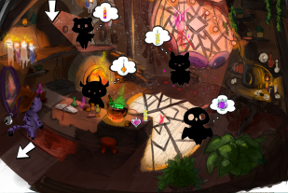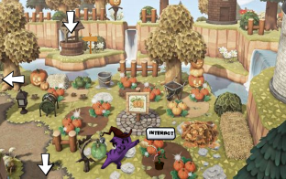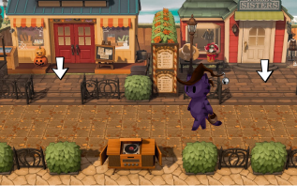

Scope :
MVP :
➔ Character movement and interactions and NPC dialogues
➔ Shop menus
➔ Activities:
◆ Brewing station
◆ Crystal gathering
◆ Gardening
➔ Shop :
◆ 3 types of brews
◆ 3 types of plants/crystals
➔ 3 customizable elements
Advanced :
➔ Shop
➔ More brews
➔ More plants/crystals
➔ More custom options
➔ Candle crafting
➔ Village (with shops and custom elements)
➔ Random events (pests, rain, side quests)
➔ requests
➔ Day/night cycle

Gameplay intention :

Mechanics :

Potion Brewing :
In Purrfect Brews, the player will be able to collect recipes, either by discovering every resource required for said recipe, to brew a selection of potions. There are three types of brews : pawtions, purrfumes and meowdicines. If a recipe isn’t discovered, it isn’t displayed either in the inventory journal, nor in the brewing recipe book.
Indeed, some of your clients will sometimes be in need of potions, this need being expressed in a little bubble above their head when they enter the shop. Up to three clients can be in the shop at the same time during the day (change depending on shop’s upgrade). No clients will show up during nighttime.
Once their request is satisfied, they collect their order, pay and leave, allowing another customer to enter.
To enter the brewing counter mini-game, the player must interact with the Brewing Station by placing themselves behind the counter.
When brewing, the game switches to a first person view. The player has several actions available. To successfully brew the desired potion, the player has to carefully follow the recipe’s steps, using a Recipe Book that shows what to do in the correct order. To do so :
- The 3 correct ingredients must be added in the right order and at the right moment.
- The heat (low, medium, high, too high) must be controlled and correct. Unless turned completely off, the heat increases slowly automatically.
- The stirring has to be executed at the right moment (there is no right way to stir) by dragging and dropping the Spoon in the Cauldron.
A preview of the brewed potion appears once the player hits the Finish button (ending the brewing minigame). Once a potion is brewed, the player can decide where to put it (on the counter, in the inventory or sell it to a client). The player can go to the counter to place a brew on it or remove one.
A potion can be failed if :
- The temperature is too high and not corrected for too long
- The chosen ingredients do not match any recipe or the steps weren’t executed in the right order
- If the player exits the brewing station, any used ingredient will be lost in the process.

Candle Crafting :
Some of your clients will sometimes be in need of candle works, this need being expressed in a little bubble above their head.
Candles require wax (that can be purchased in the materials store) and magic crystals (that can be gathered in the mine or bought in the materials shop when available), each with their own magical property.
When interacting with the candle station, the game switches to a first person view, similarly to the potion brewing game. The player has several options available and will have to successfully replicate a candle shown in a preview. The right combinations create enchanted candles. To do so, the player has to :
- Melt the wax of the desired color (3 colors available, that can be mixed) - Grind the crystals to dust in the mortar
- Combine the right crystal dust (6 available, each one having its own property. They can be combined) to the wax. Two crystals maximum can be added. - Mind the fire underneath the wax that grows hotter as time passes.
The current candle’s magic properties are displayed in the HUD during the craft. These properties are displayed and updated after one crystal has been put in the mortar so that the player knows what effect adding another crystal would have on their crystal dust. After they’re satisfied with their selected crystals, they can grind them to dust and pour them in the wax, this updating again the property of the final candle. Once a candle is crafted, the player can decide where to put it (on the counter, in the inventory or sell it to a client). The player can go to the shelves to place a candle on it or remove one.
The player has access to the list of the requested candles, that show the candle’s properties, color and the portrait of its requester.

The Pestle is automatically picked up when dragged into the mortar and can be used to grind the crystals down. It can only be clicked if one or several crystals are in the mortar, and is automatically put back down when the crystals are completely grinded. The candle’s shape varies depending on its color.
Once placed in the mortar, the crystals can still be removed by clicking the discard button, until they are hit with the pestle at least once without being permanently removed from the stock. Once grinded, the crystals can still be discarded but by clicking the mortar the used ones remain consumed.
When a crystal is added to the mortar, the properties page is updated to show what combinations are possible with the selected crystal.
The wax can be added at any moment and in any order. Once placed in the cauldron, it can be discarded by clicking the wax bowl, but the pellets used remain consumed.
A candle can be failed if :
- The temperature is too high and not corrected for too long
- If the player exits the crafting station, any used ingredient will be lost in the process.

Crystal Gathering :
To fuel up their candles, the player can collect magic crystals, each having specific abilities.
To find crystals, the player can either buy some from the Materials Shop (if available) or try and find them in the Mines. Interacting with a crystal slot has the view swapping to first person. To successfully mine a crystal, the player has to:
- Click on a wall portion to search it
- Hammer the wall (between 2 and 5 hits) to discover and remove rocks. Hammering a crystal too much (once more than needed) breaks it - Dust off the crystal entirely to collect it
When hammering the wall, two specific “hits” will be randomly available to the player : a strong and light one. These hits can be anticipated thanks to an indicator at the top of the screen and the cursor image swap. The player can only hit crystals, and will thus have to sacrifice some of them in order to gather specific items.
Each mine wall has consistent crystal slots that re-spawn every morning. When the player is near a mining slot they can interact with, it will shine to show its possible interaction. When all the crystals are gathered, the highlight is turned off.
The player can gather 1 to 3 crystals by slot. A crystal cannot be collected if its max amount has been reached in the Inventory.
If one of the player’s crystal inventory slots is full, the corresponding crystal on the wall can be hammered but not brushed and therefore gathered. If the player tries to brush it, the full stack animation is triggered.
When a crystal is gathered, it is added in the player’s purrse and an animation is triggered, displaying the gathered crystal’s preview and the quantity added.

Water / Plant Harvesting :
The garden is the place where the player can nurture and gather crops that will later be used when brewing potions. It has several slots where seeds can be sown to the player’s liking : each plant has its own slot, though the player will later on be able to rearrange their garden. Once a plant is sown in a slot, it can be removed by the player at any given time, but doing so deletes entirely the plant.
Plants can also be watered twice a day (once in daytime and once in nighttime), thus ensuring their well-watered status (that’ll give out more drops once matured).
Each crop has 4 growth stages :
- seeded
- budding
- flowering
- matured
The way they’ve been cared for also influences their mature state :
- matured without product
- matured with product
- matured with product ++ (plant well watered)
Each plant has specific shading needs and will grow faster if they are met.
Harvesting a normal crop will give 1 to 3 plants to the player while a well watered crop will give 3 to 5 of them. When harvested, the crop goes back to its mature state + without product. When the player has their inventory full of one type of plant/product, they cannot harvest it. The harvest action icon is grayish and thus inaccessible.

When a plant is harvested, it is added in the player’s purrse and an animation is triggered, displaying the harvested ressource’s preview and the quantity added.
Crops can sometimes be attacked by Pests that will stop their growth. The player has to interact (E) with these infected crops to shoo the Pests away. Using specific crystals on plants can also have various positive effects (no pests can spawn, accelerated growth, max resources improved, etc)
A shovel can be found in the garden’s first extension (Garden Upgrade 1). The player can interact with this shovel, visually picking it up, and launching the Plant Removal mode after a confirmation message. In this mode, the player can walk up to the plant slots that currently contain a plant and remove the contained plant by pressing the E key. All other actions (Watering, Harvest, Pest Removal) aren’t available in this mode. As long as the player holds the shovel, they cannot exit the garden. To put the shovel down, they must go back to where they picked it and press the E key again (no confirmation needed).

Interactions / Wandering :
The player can wander through the streets, shops and notorious places of Meowsburrough at any given point in the game. They can interact with vendors or villagers by standing near them.
The player will sometimes come across some quests that can be fetched by interacting with the quest giver. These quests can be fetched in the Plaza, Cafe or Main Street.
When the player is near a plant they can interact with, a bubble will appear above the player to show the possible interaction.

Upgrades :
Buying upgrades allows the player to experience the world of Purrfect Brews to the fullest by :
- Progressing through the game
- Expanding the shop to maximize your production and accommodate more clients - Expanding the Inventory to stock even more plants / crystals
- Expanding the gathering areas (garden and mine) to allow for more brewing and crafting
- Visually enhance the game and make it even more cozy, as the environment (Main Street and Café) get more furnished with each upgrade. (c.f. : Café)

NPCs :
The player can interact with various NPCs that roam the Main Street, the Plaza and the Café. They can also enter the player’s shop, becoming Clients.
Pressing the E key next to an NPC triggers a random dialogue line among a pool of Random, Self Care and personal lines. Even though all NPCs share the pool of Random and Self Care lines, each NPC has 3 custom lines (the personal lines) that no other NPC can display.
NPCs roaming the plaza can sometimes request a special object (crystal, ingredients, pawtion, etc.). If the player brings them the requested item, they grant them a great reward (meowney, or rare item after the player has already completed a certain amount of requests).

Systems :

XP system :
The player can gain XP by brewing potions and making candles (even failing is progress !) Gaining enough XP leads to the player leveling up, and to them subsequently unlocking new types of plants, crystals and titles.
This XP gain can be distinguished by the way townsfolk will refer to the player : with each new level, the player will gain a Title, also indicating the appearance of new objects in the shops (indicated by “New stuff!” panels in front of them)
List of unlockable titles :
● Witchlet / Witchling (0-1)
● Baby Witch (1-2)
● Trainee Witch (2-3)
● Witch Apprentice (3-4)
● Witch (4-5)
● Grand Witch (5-6)
● Witch of the Wilds (6-7)
● Mighty Witch (7-8)
● Magus Pawpus (8-9)

Shops :
Four shops can be found in the Main Street :
1. A plant nursery, where the player can buy seeds and plants (and later on, Pets)
2. A materials shop, where the player can buy wax, crystals and upgrades (Shop, Garden, Mine and Inventory)
3. A furniture shop where the player can buy skins for their shop
4. A clothing shop where the player can buy clothing skins for themselves
Each store’s stock has 4 items that change day by day (except the Wax in the Materials Shop, that remains in stock everyday). As the player level increases, new items are unlocked and can be sold.
A traveling salesman can spawn regularly on the Plaza (50% chances to spawn every morning. If does spawn : cannot spawn anymore for 3 days. If doesn’t : checks again the next morning). They can sell 4 items among all the available crystals and plants the player has access to, according to their level. They tend to have the rarest items for sale.
At some point, the player will unlock Pets, little creatures buyable in the plant nursery that will follow the player everywhere.
The player can pet them

Special places :
Two additional noteworthy places are located to the main street’s extremities :
- The plaza, where villagers can hang out and some quests can be fetched - The cafe, that displays the player’s progression and the team’s credits
While these places are locked at the beginning of the game, the player will be able to get access to them by gaining enough XP and unlocking their specific quests.

Day / Night cycle :

Each cycle is 20 min long. Some actions are only available by day / night. Players can interact with a cat basket located in the shop to skip the current time cycle. The plants’ growth cycle isn’t impacted by this timeskip.

Inventory :
The player’s inventory is displayed through a magic journal that keeps count of the number and quality of the gathered materials along with their visual preview. The journal has 5 sections :
- Plants
- Seeds
- Crystals
- Special objects (quest-related)
- Recipes
Each item has a stock limit in the inventory. When reached, its icon becomes grayish and the quantity number turns red. This limit can be increased by buying Inventory Upgrades in the Materials Shop. There are three levels of upgrade available to the player : level 0 (default), 1 and 2.

Purrse :
The player can also store a certain amount of pawtions and candles (from 1 to 3 depending on the upgrade the player has) in their Purrse, which can be accessed in the inventory. They can carry the items stored in their purrse and deliver them to the NPCs (if they have a matching special request).

Items stored in the purrse can be stored on the counter or shelves (if enough room) or taken from the counter or shelves.
If an item stored in the purrse matches a request the player has accepted, a tick and the face of the NPC whose request matches will appear next to the request and item preview.

HUD :
The game’s HUD is relatively simple, only displaying the time when the player’s been idle for a moment. When approaching an element that can be interacted with, a bubble will appear showing said interaction (plant a seed, harvest a plant, access to a mining slot, speak with a villager…). [Cf. Wireframes HUD]

Skins / Customizations :
The player will be able to customize their character and their surroundings by buying specific cosmetics at the Furniture Store (shop appearance) and the Clothing Store (character appearance).
These customizations can be applied to said shop or player either directly in the Stores or by interacting with the Mirror or the Chest in the player’s shop.

Activities :
Sometimes, an NPC can ask the player if they want to perform an activity with them (dialogue line randomly picked among the dialogue lines database). The player can select if they do want or not.
If they select NO, nothing happens.
If they select YES, the player and the NPC are transported to the corresponding hidden tiny scene, where they can wander and talk to the NPC for as long as they want. Every hidden scene displays a single path that the player can walk to go back to the Main Street.
Resources can be collected in those scenes (crystals/plants)
The available activities are :
- Fishing (Lake)
- Hiking (up a cliff, above the forest)
- Go for a stroll (magical clearing)
Time continues to pass while the player is performing an activity.

Game Loops :
Macro :
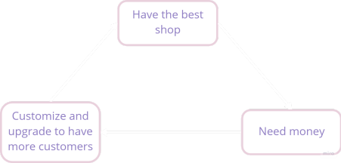
Middle :
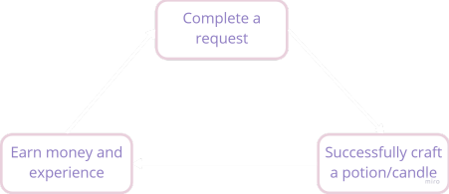

Micro :
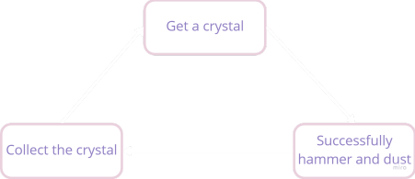

Level design :
Global map :
PurrfectBrews_LDD
Figma : https://www.figma.com/file/Mmqv49J3cnQWwxTGGhSKNu/Untitled?node-id=31%3A16
Purrfect Brew’s global map is divided in three types of scenes lighting / ambient - wise :
- Interiors (Player shop, Plant Nursery, Materials shop, Furnitures shop, Clothes shop, Cafe)
- Exteriors (Garden, Main Street, Plaza)
- Cave (Mine)
When traveling in between the scenes, a small transition will mark the effective scene change.
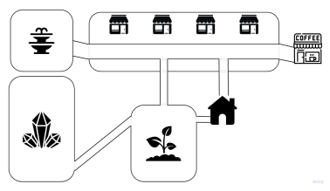Ingame map

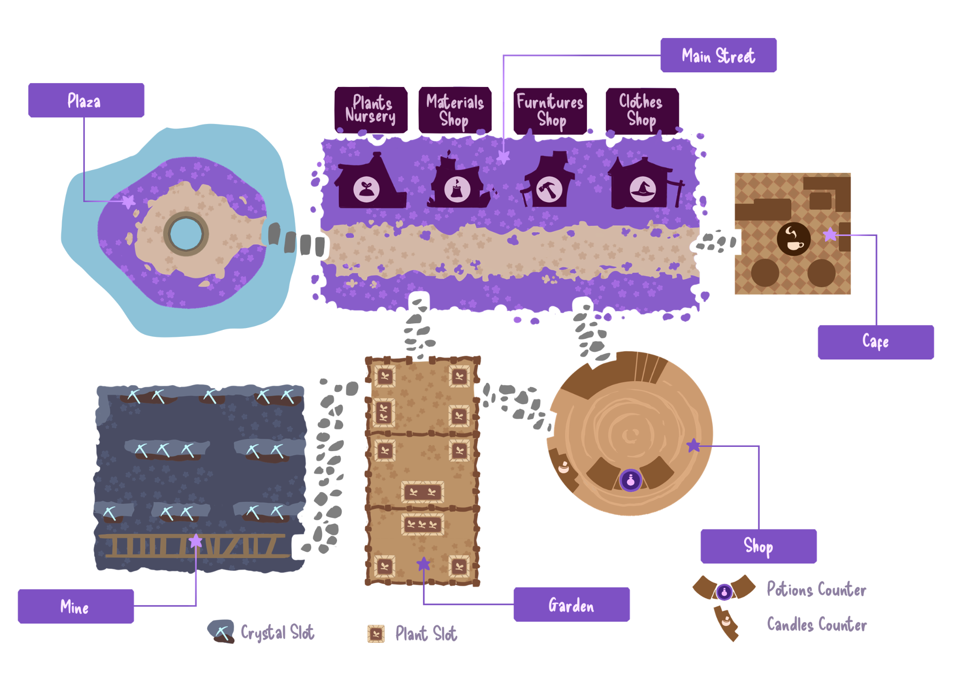
Global map LD

UX / UI :
Wireframes
Flowgraph :
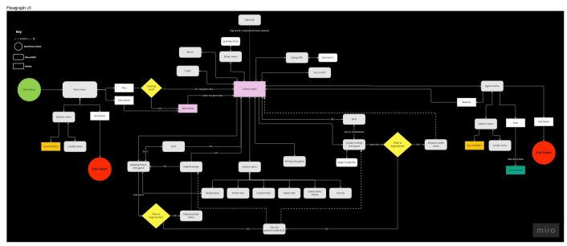

Concept Art :

Environment :
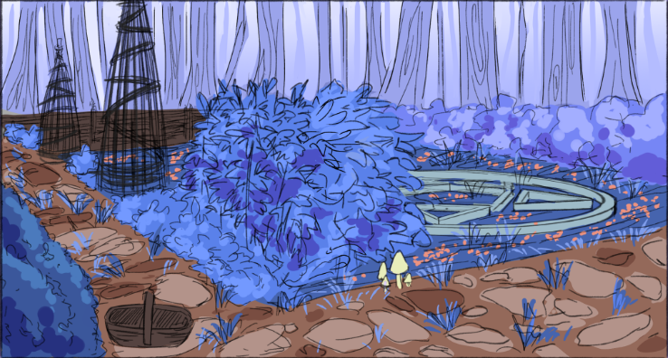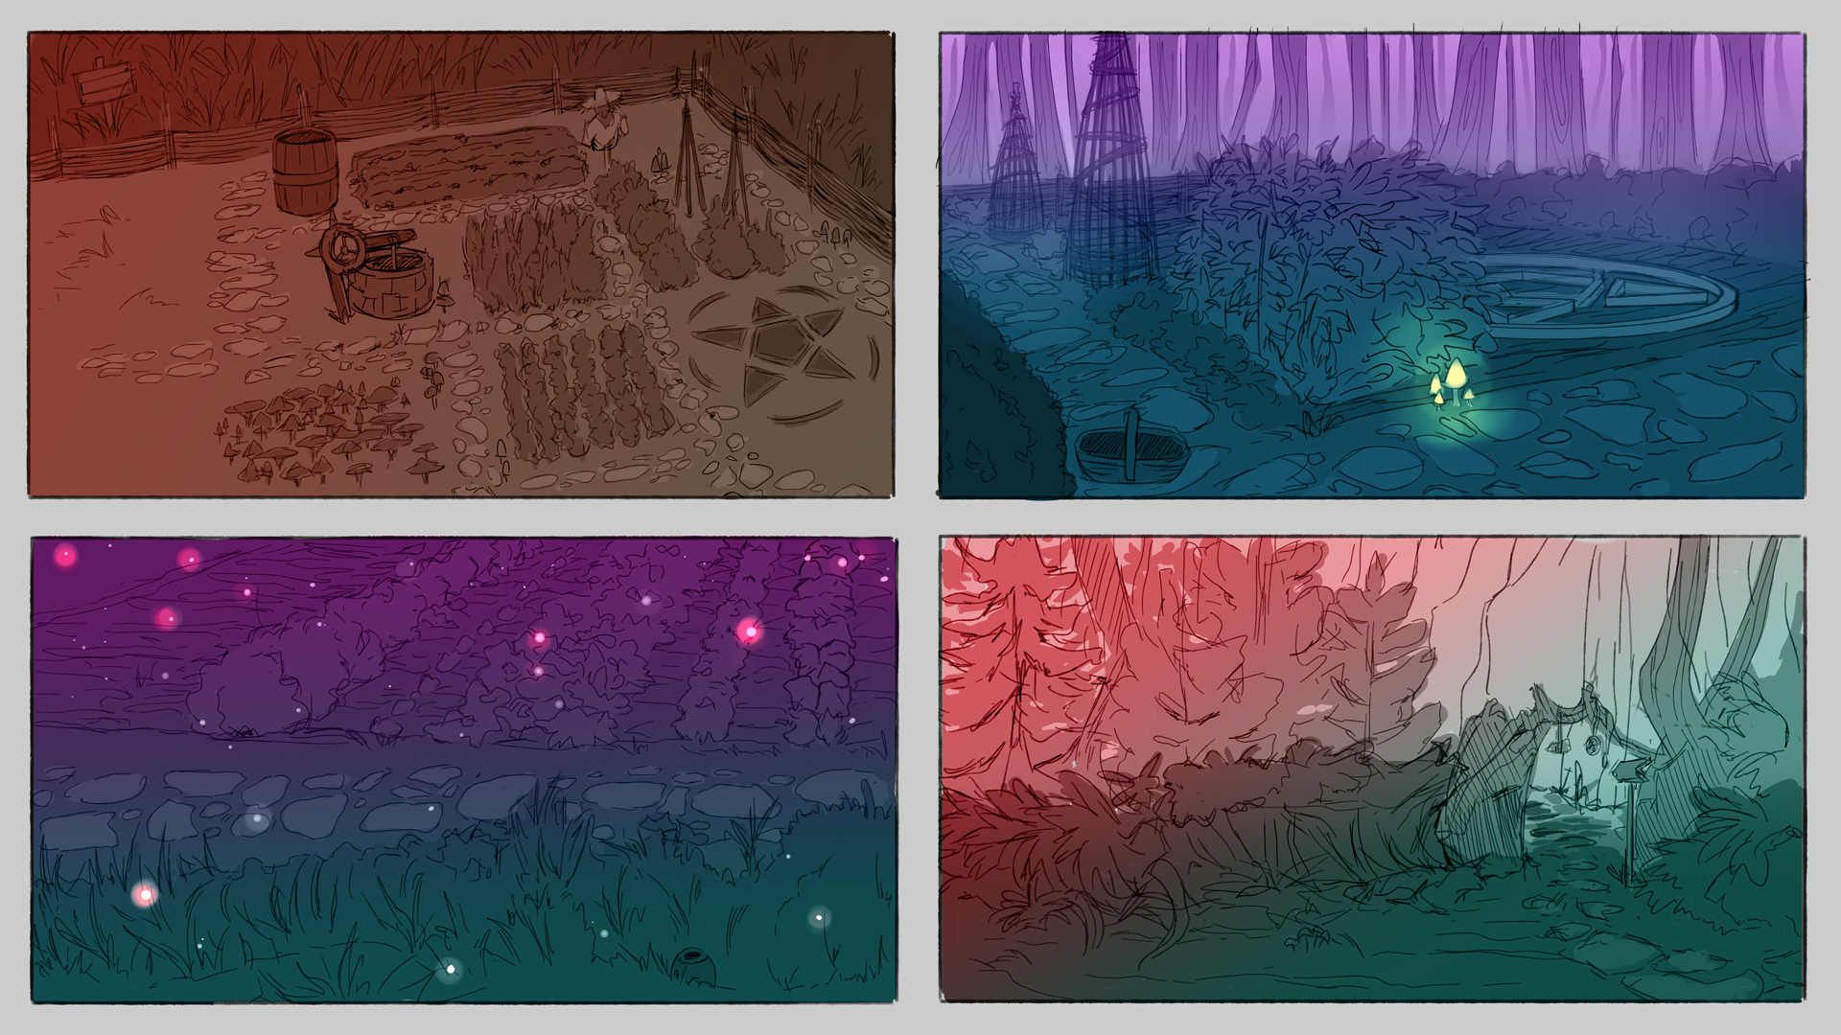Player’s garden
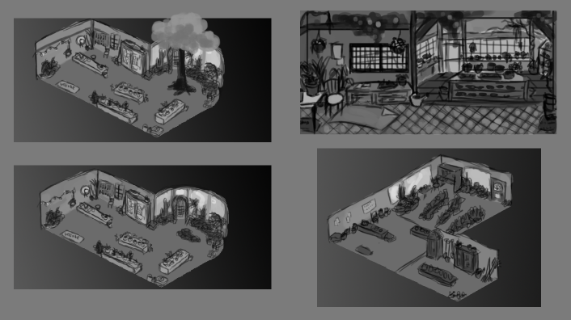
Plant Nursery (Interior)
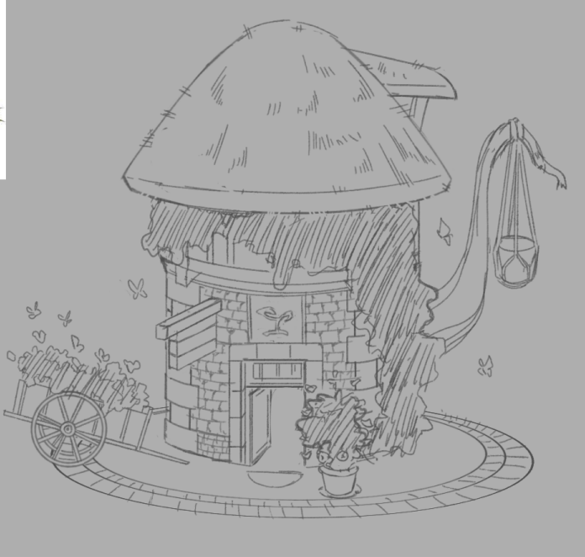
Plant Nursery (Exterior)
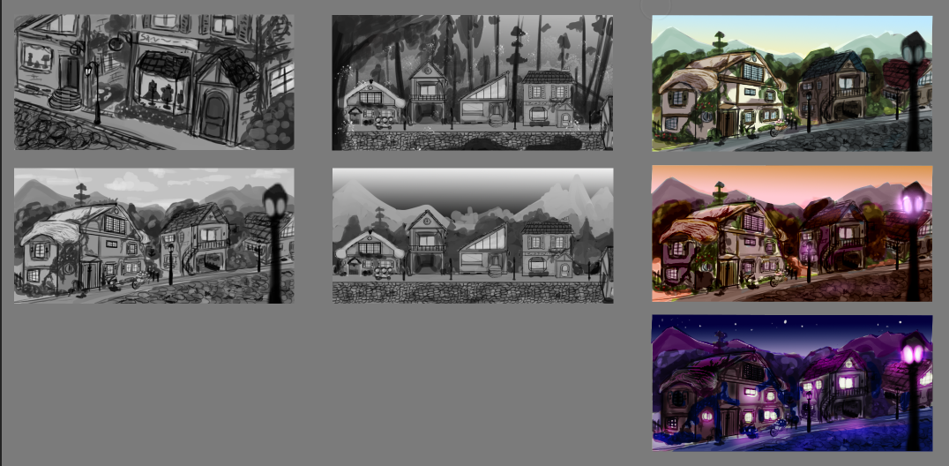
Main Street (B&W)
Main Street (Colors)

Props :

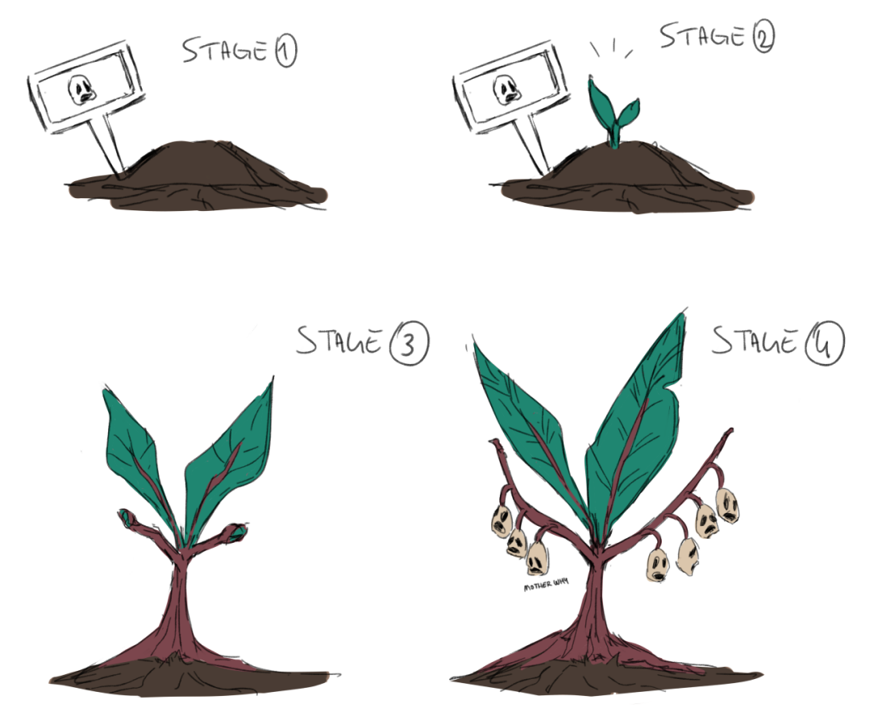

Characters :

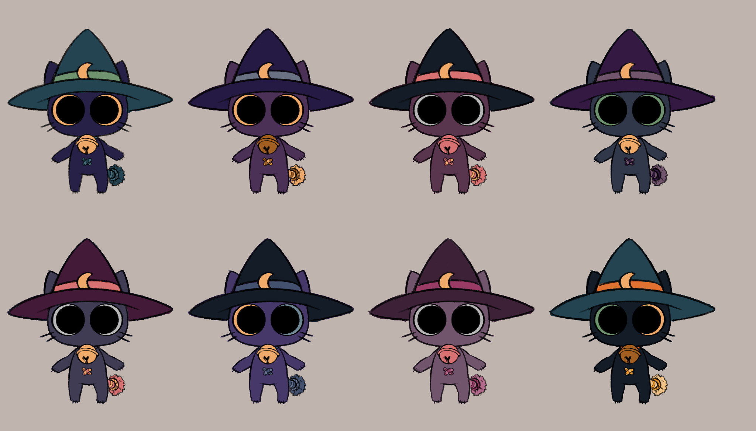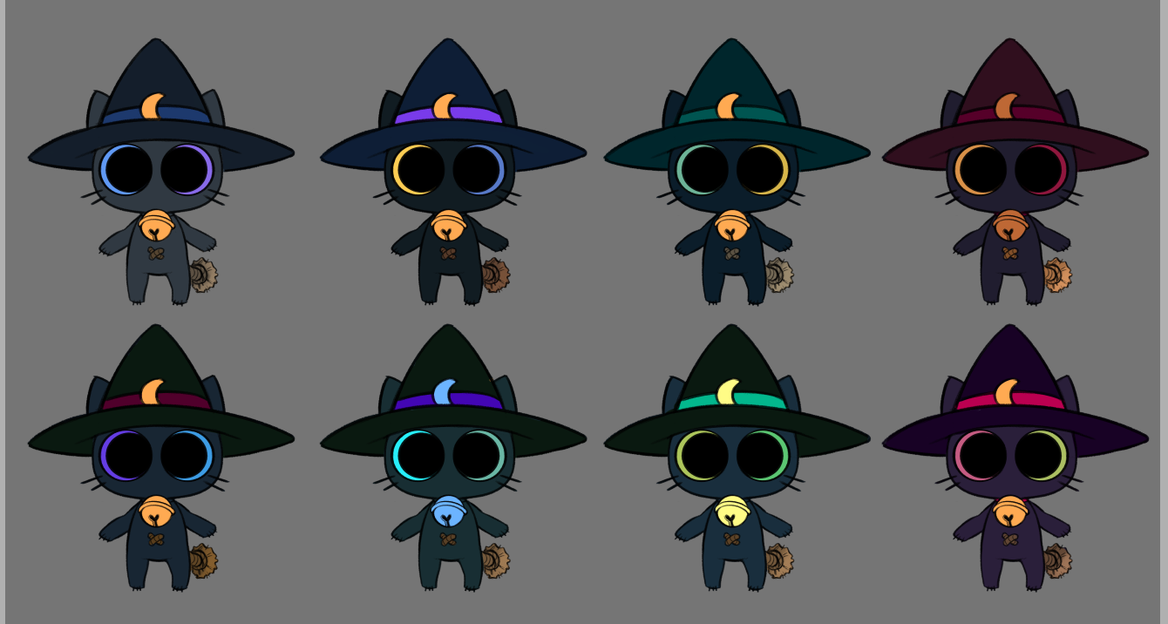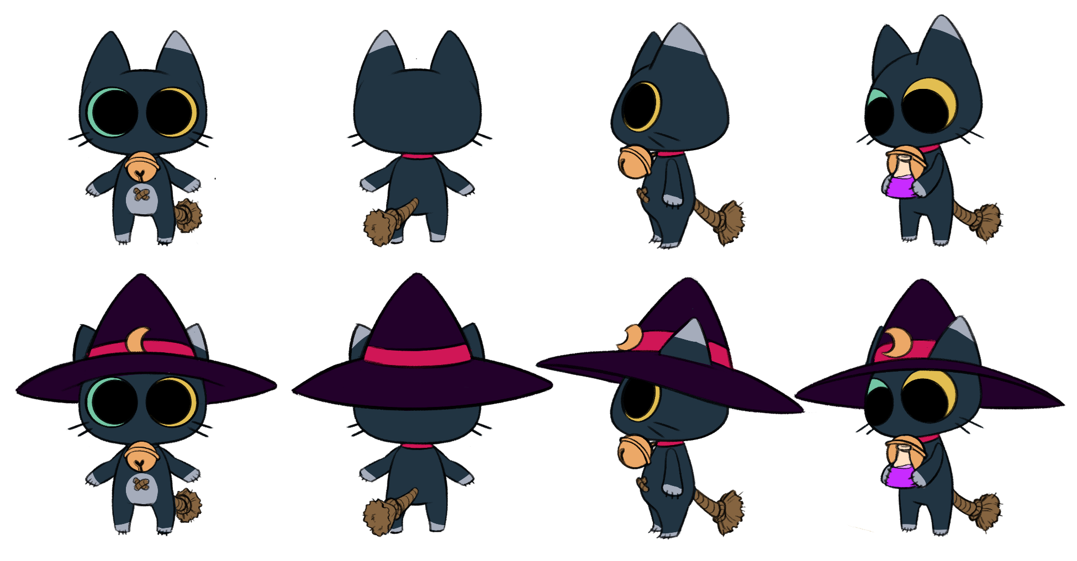

2D Assets :

Environment :
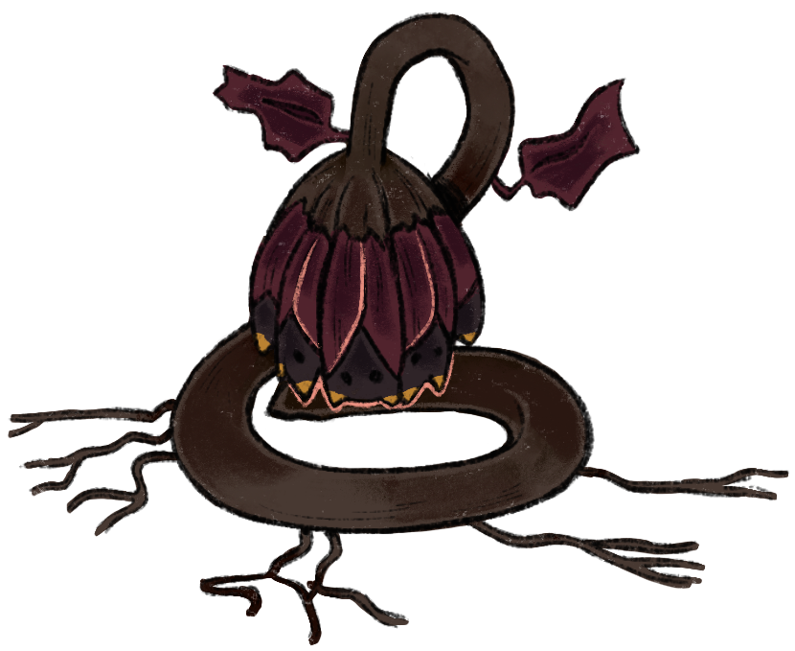
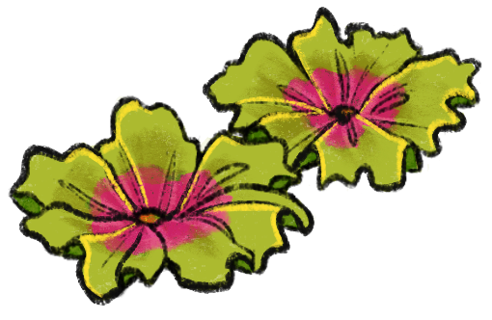
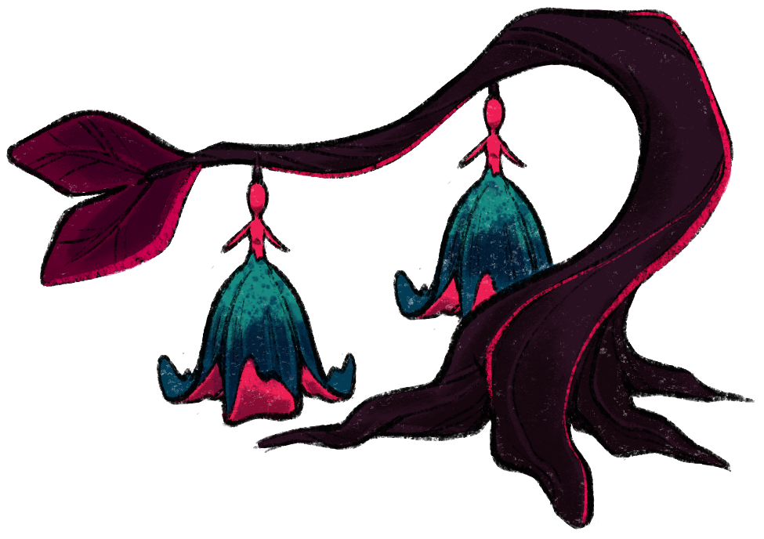
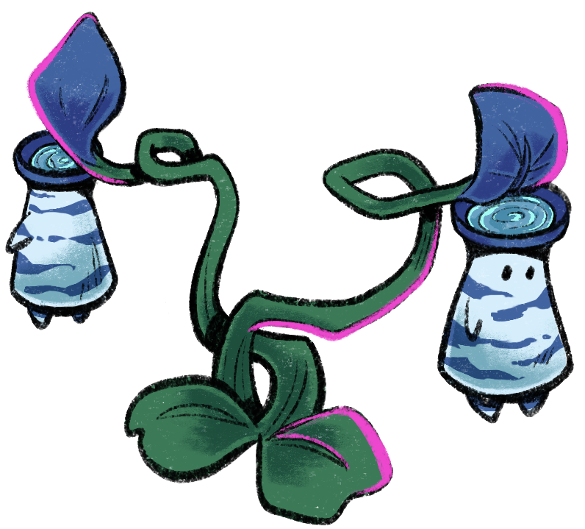

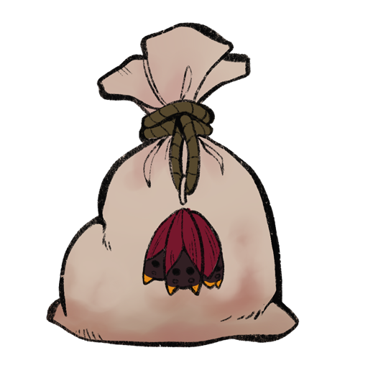
Props :

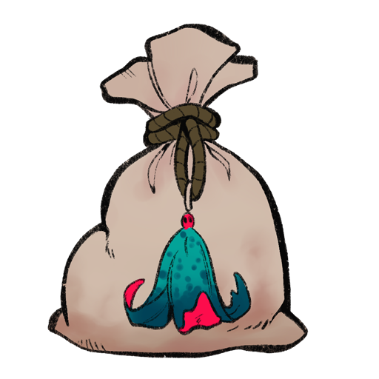
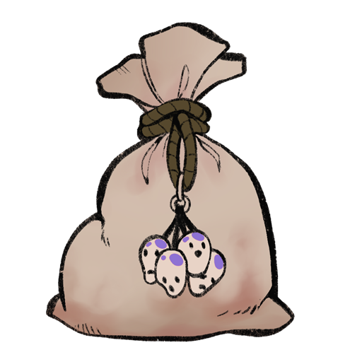
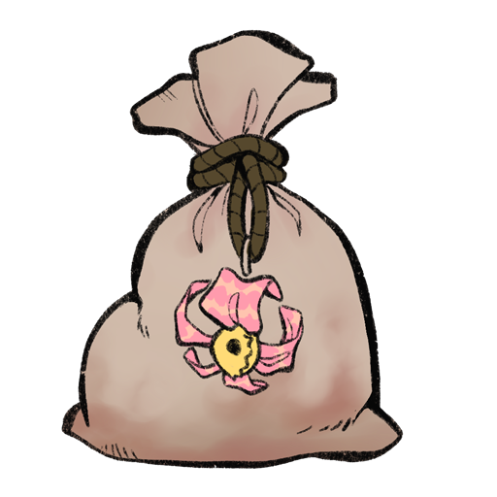
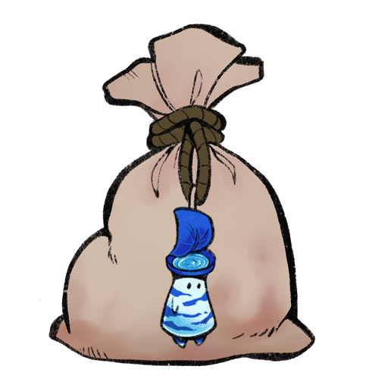
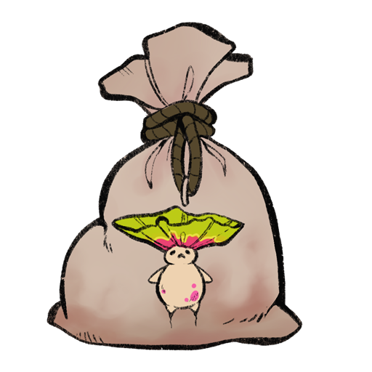

Characters :

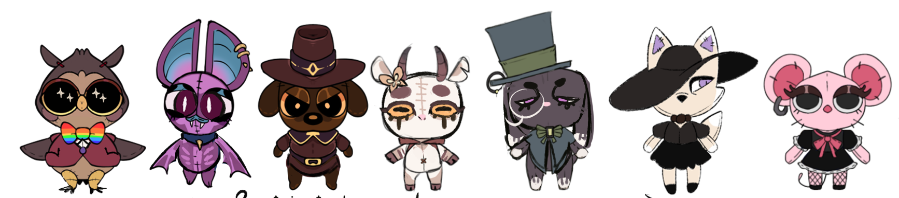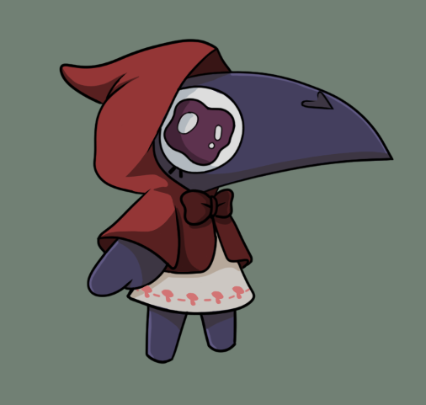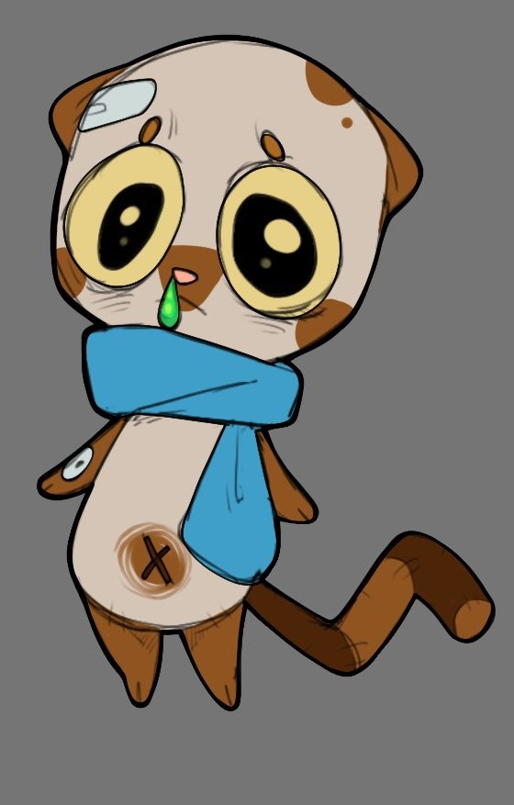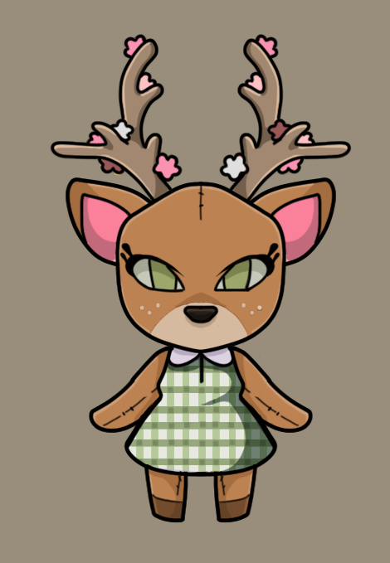

3D Assets :

Props :
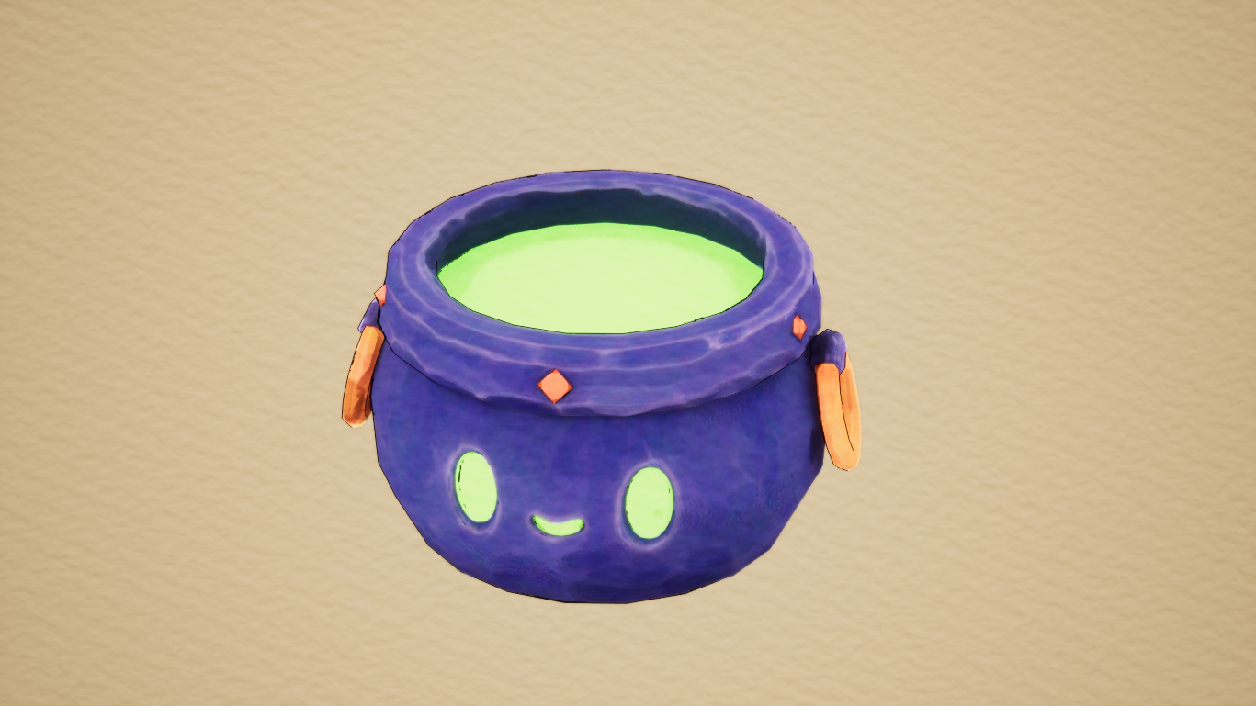
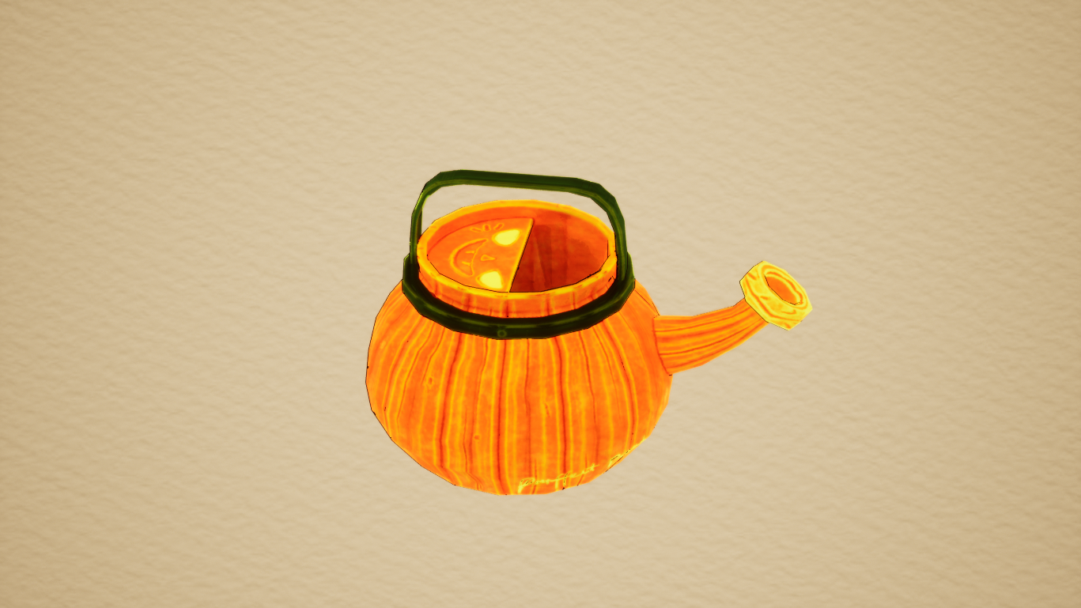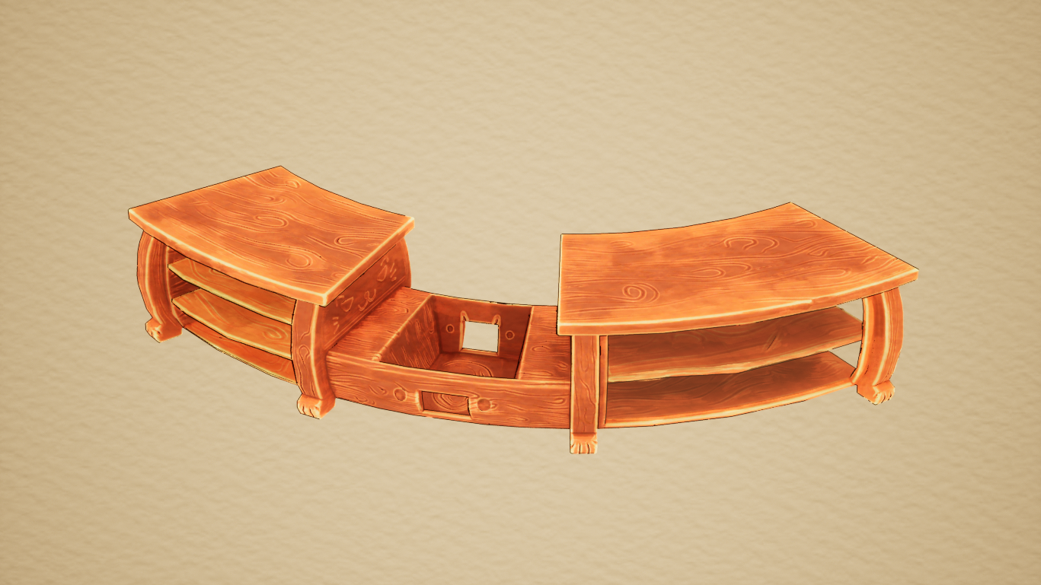
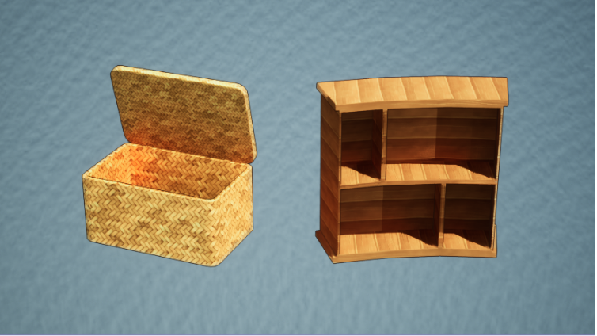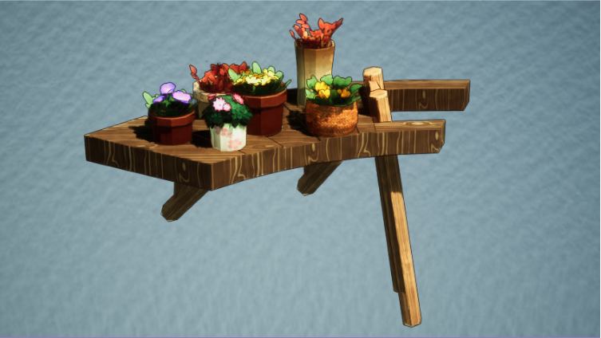
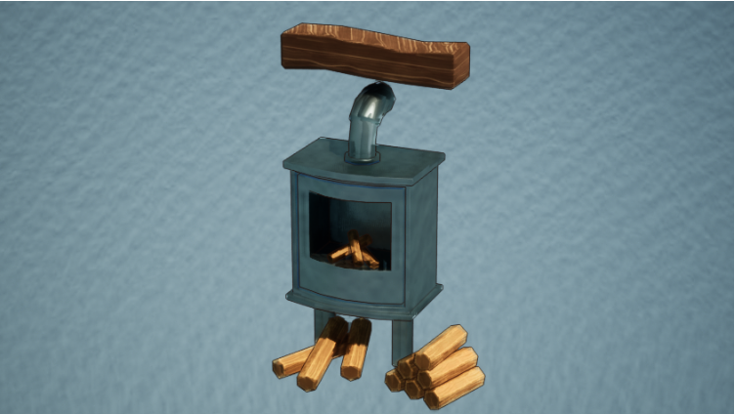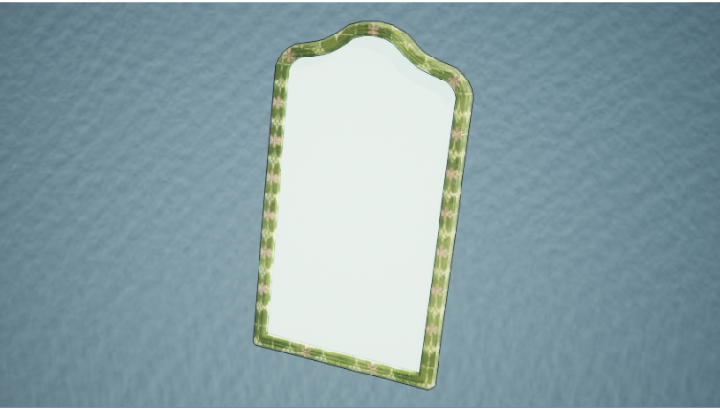
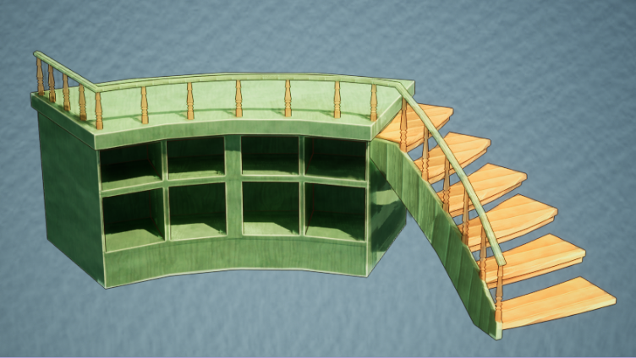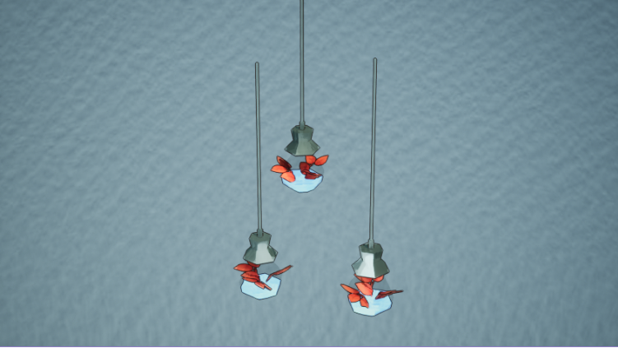
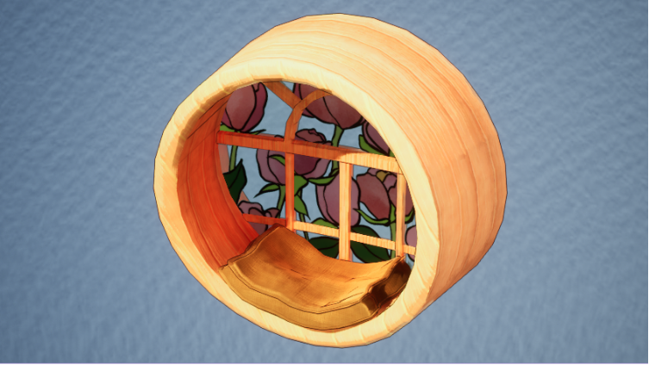

Characters :
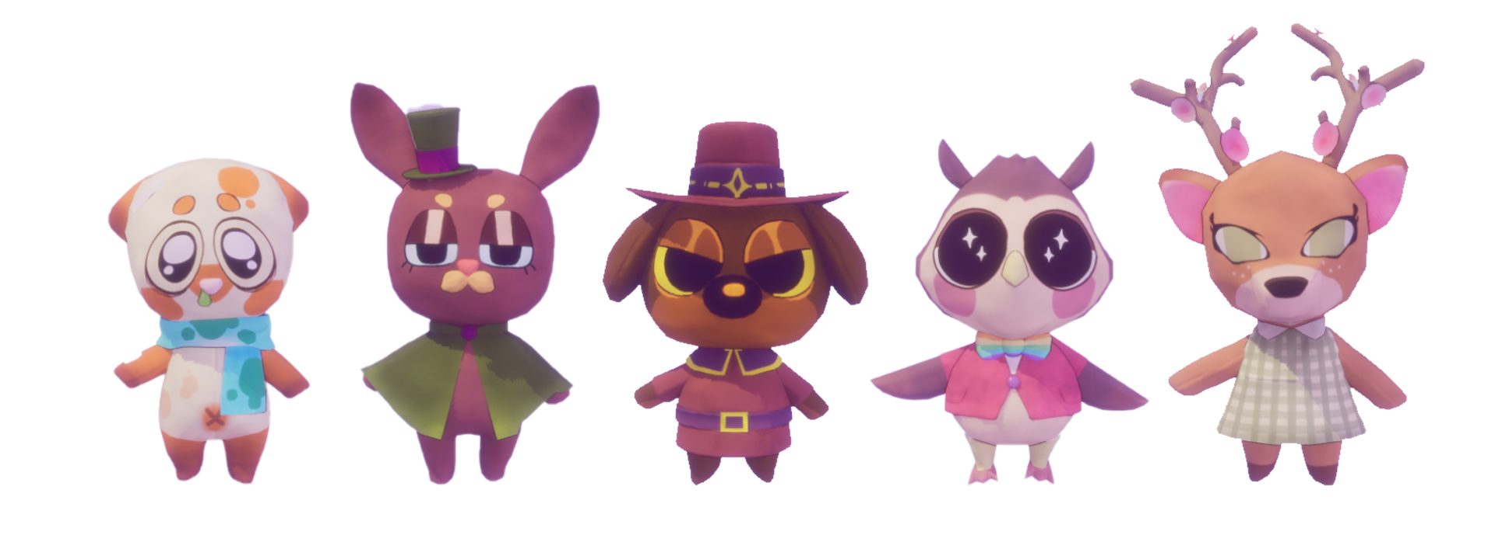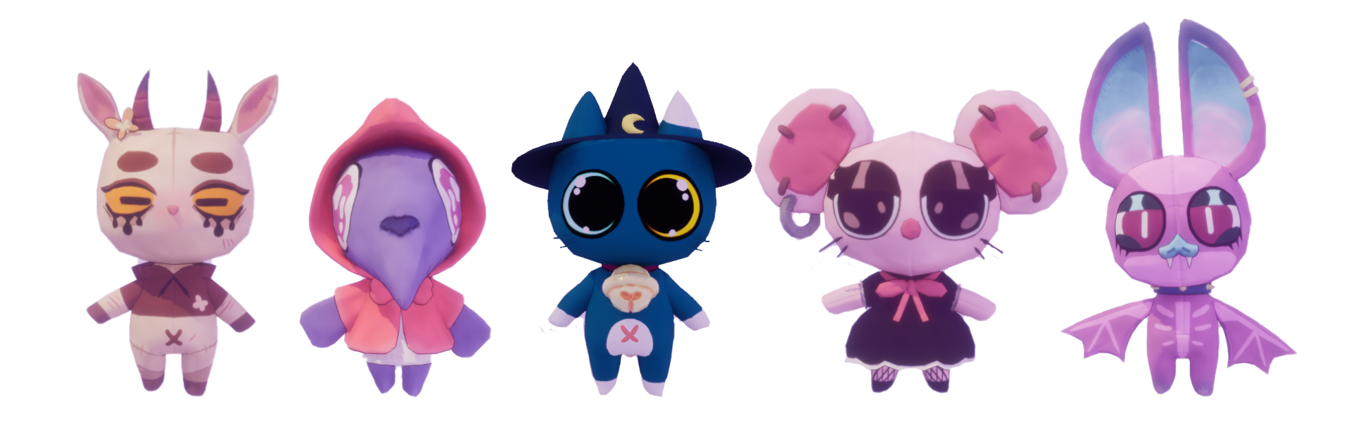

Environment :
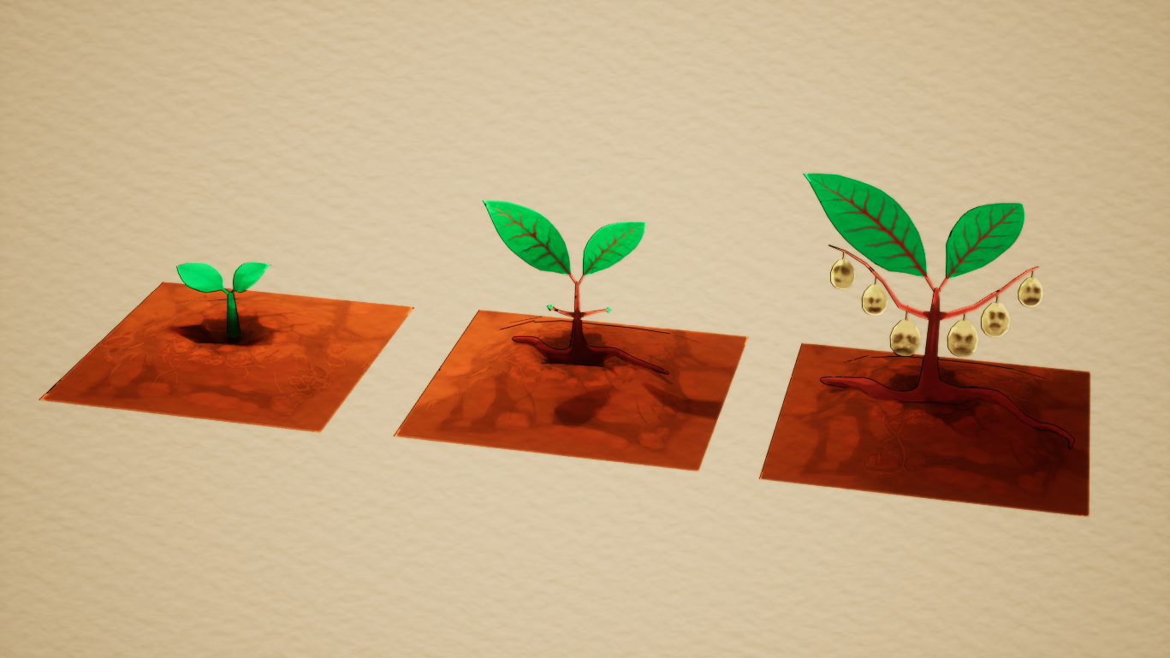

References :

Gameplay :
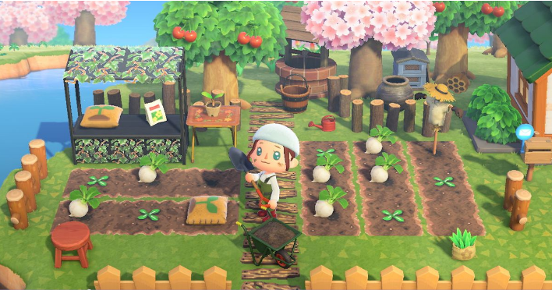Animal Crossing New Horizons : Gardening - Camera
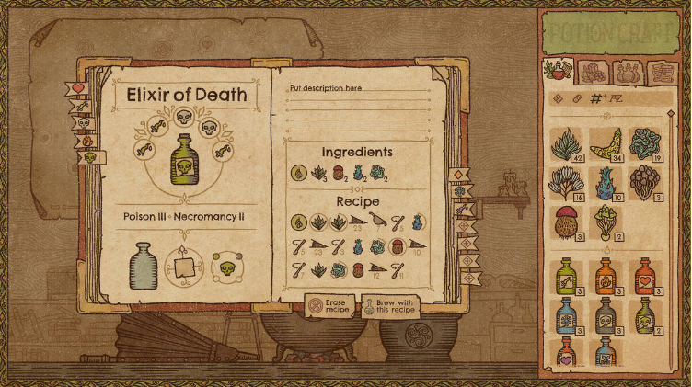Potion Craft : Brewing + Journal
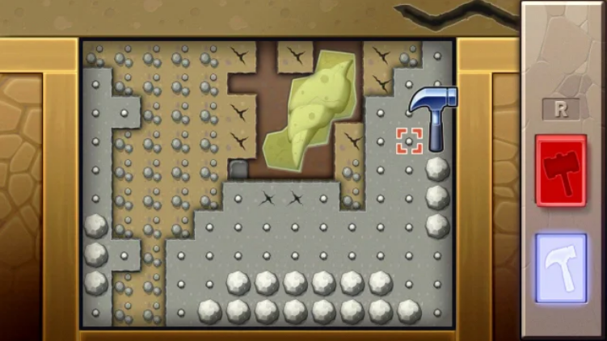Pokemon Diamond / Pearl : Mining mini-game
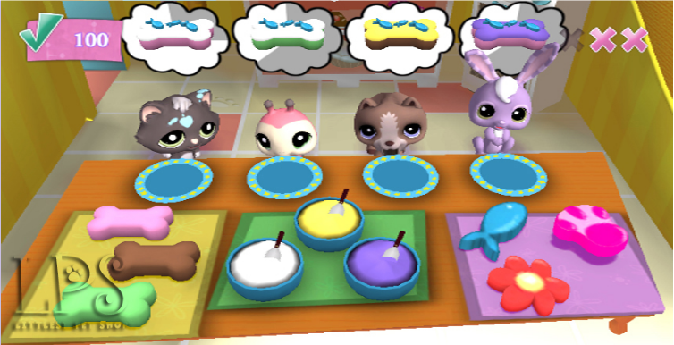Littlest Pet Shop : Clients’ requests

Art :
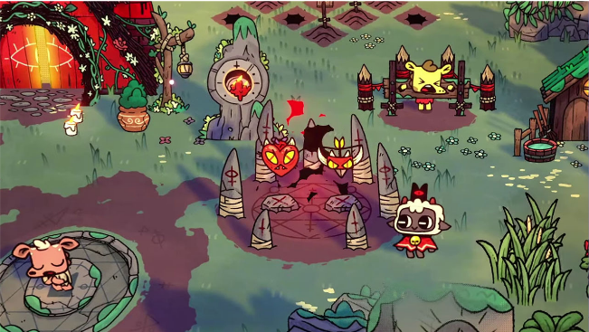Cult of the Lamb
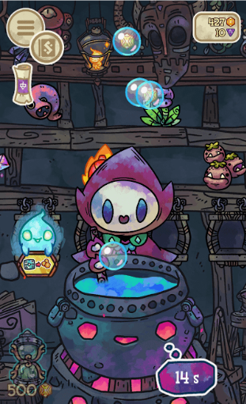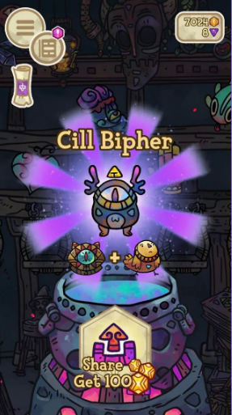
Alchademy
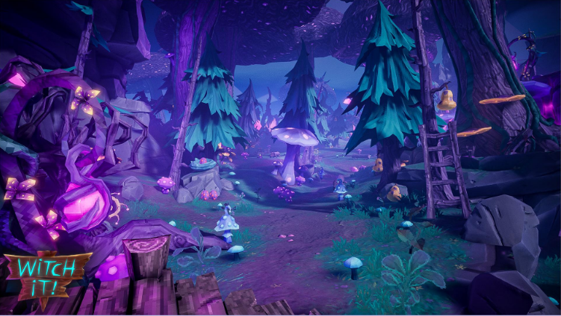

Witch it !
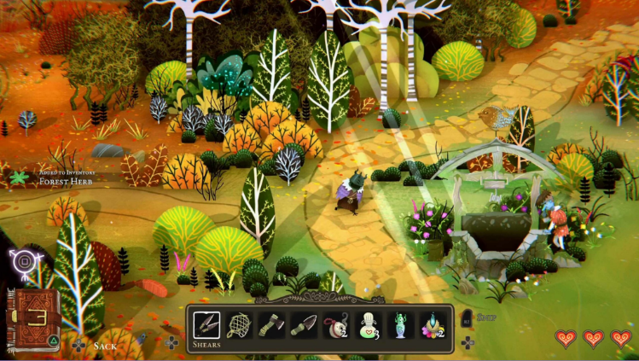
Wytchwood

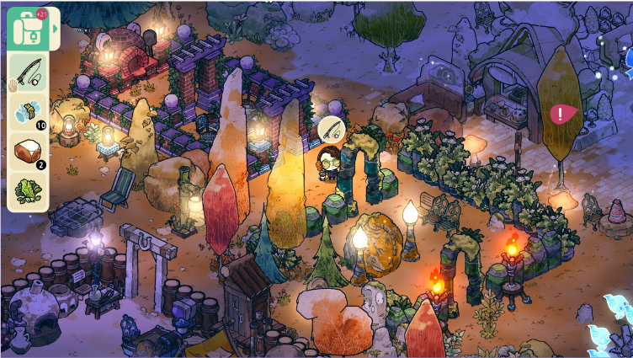

Cozy Grove
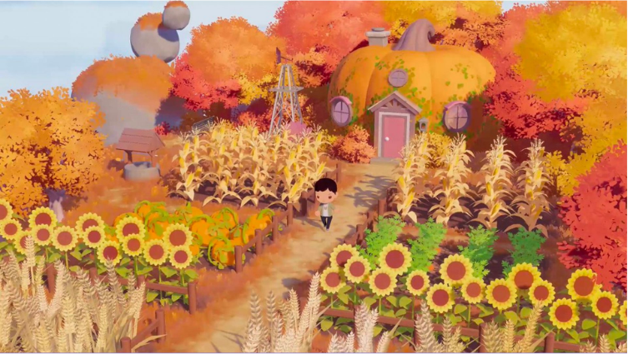
Puff Puff Island Skies

Music :

Intentions :
PurrfectBrews_Music
Global mood : Cozy, Witchy, welcoming
Indoor : Cosy, warm, basses, chill, cocooning, embrace?
Outdoor : light, aigus, magique/mystique

References :
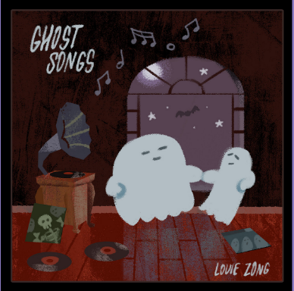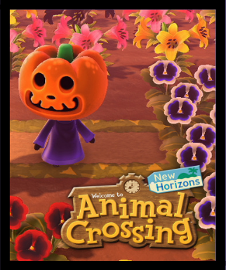
Ghost Songs - Louie Zong ACNH - Halloween theme

Misc. Documents
Onboarding :
NewPurrfectOnboarding
Level Design Document :
PurrfectBrews_LDD
(https://www.figma.com/file/Mmqv49J3cnQWwxTGGhSKNu/Untitled)
Narrative Design Document :
PurrfectBrews_NDD
Sound Design Document :
PurrfectBrews_SDD

The Purrfect Team

GD | GA | TA
Allen Fanny | Alvaro y Fuentes Alice | Afyouni Myriam
Lamouche Emma | Besson Anaëlle | Bezet Anaëlle
Papin Amaya | Deprun Annabelle | Chen Anni
Ravera Delphine | Meyer Fa

